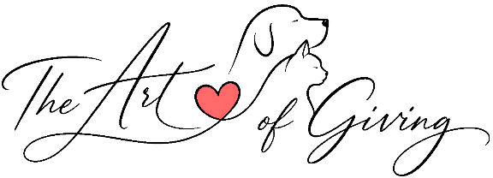
CERTIFICATE OF AUTHENTICITY

This certificate confirms that the artwork described below is an original, hand-painted work created by Alexander M Williams.

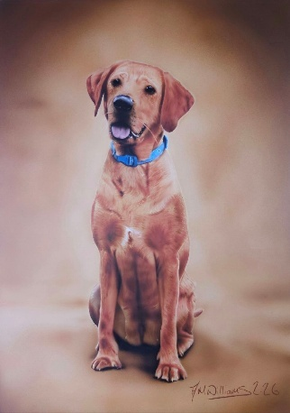
ARTWORK DETAILS
Artwork Title:
Artwork ID:
Security Seal Number:
Date Completed:
Medium:
Surface:
Dimensions:
Orientation:
Framed:

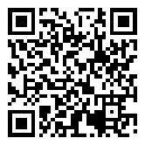



VERIFICATION
Scan the QR code to view the official artwork page, including photographs, the story behind the painting, creation videos and verification details.

STATEMENT OF AUTHENTICITY
I certify that the artwork described within this certificate
is an authentic original created solely by me.

Alexander M Williams Date

Every original artwork is individually catalogued within the Alexander M Williams Artist Registry and assigned a permanent Artwork ID and unique Security Seal Number.
www.kindnessgivingart.com
axelwill@live.com
@The_Art_Of_Giving
QR Code
Artwork Image
CARE OF YOUR ARTWORK
- Display away from prolonged direct sunlight.
- Avoid excessive heat, humidity and damp conditions.
- Dust gently using a clean, dry microfibre cloth.
- Do NOT use water, cleaning products or solvents on the painted surface.
- If framing or transporting the artwork, ensure you carry by the edges and avoid touching the painted surface.

ABOUT THIS ARTWORK

STATEMENT OF AUTHENTICITY
I hereby certify that the artwork identified above is an original, one-of-one painting created entirely by me. It has been completed using professional artist-quality materials and has been personally inspected and approved before leaving my studio.

The original artwork bears a uniquely numbered tamper-evident security seal permanently affixed to the reverse. This certificate corresponds exclusively to the artwork carrying the Security Seal Number listed above.

The Artwork ID and Security Seal Number are permanently recorded within my artist registry for provenance and future verification.

Authorised reproduction, if any, will only ever be produced by or with the permission of the artist.

